The QTK Ardis optimization is run from SFE. It works in the following manner:
- They have a custom table named: ArdisOptimizationCells, where they specify the cells for which Ardis optimization should be run. Note that these are dedicated cells for this purpose only.
- When a cell from this table is selected in SFE, a custom button on the header of the main SFE form becomes visible with this caption: "Optimize Selected".
- The user is supposed to select the work order lines to process and then press the custom button.
- Once the custom button is pressed, the selected work order lines are automatically started.
- From the UserDefined1 field of their SFE custom search they get the different types of materials they optimize:
- melamine
- veneer
- sandb
- door
These types are also stored in their custom table: ArdisOptimizationTypes.
- From the selected work orders to process they get the associated sales orders. On the sales order header comment they store the Ardis .Stk files. These are the Ardis input files containing the different materials to be optimized (see Figure 1 below). Note that these files are created in a separate manner from Microvellum for each of the materials they optimize as mentioned above.
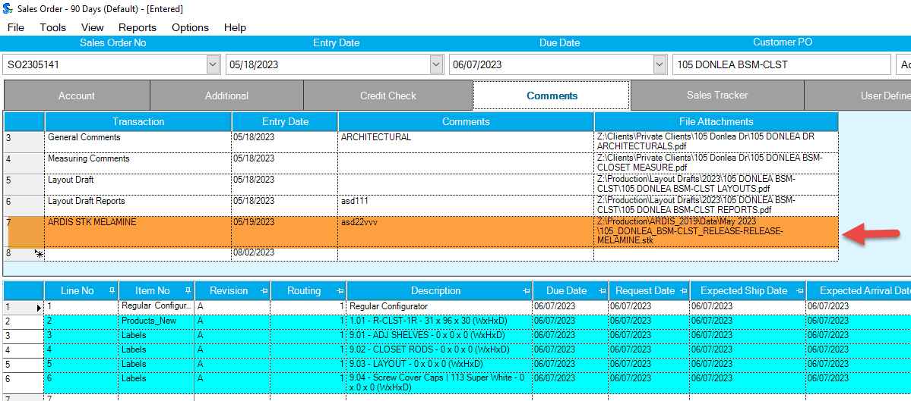
Figure 1
- Then the different .Stk files are sent one by one to Ardis for optimization.
- When the optimization is completed successfully a corresponding .R41 file is generated by Ardis. This file contains the optimized material data. Note that encountered errors are logged into the ErrorLogs table.
- Then the .R41 file is attached to the corresponding sales order via the header comment. Also, note that they use the TransactionType table to store the file types so that they can be easily identified and matched with their corresponding .Stk file in the Comments table.
- After that, the successfully processed work order lines on the SFE are automatically completed and the ones where the optimization failed are automatically stopped.

